

**Software Requirements**

**Specification**

**for**

**Forever Family Saloon**

**Version 1.0 approved**

**Prepared by Sapna Dangar, Mansi chanu, Urmila Chakrabarty**

**RK University**

**date created: 03/09/2022**

Table of Contents

**Revision History** **2**

**1. Introduction** **3**

1.1 Purpose 3

1.2 Document Conventions 3

1.3 Intended Audience and Reading Suggestions 3

1.4 Project Scope 3

**2. Overall Description** **4**

2.1 Product Perspective 4

2.2 Product Features 4

2.3 User Classes and Characteristics 4

2.5 Design and Implementation Constraints 5

**3. System Features** **6**

**3.1 Login** **6**

3.2 Registration 7

3.3 Appointment Booking 8

**3.4 Feedback** **9**

3.5 Timing 10

3.6 Catalog 11

3.7 Offers 12

3.8 Staff Details 13

**4. External Interface Requirements** **14**

4.1 User Interfaces 14

4.2 Hardware Interfaces 14

4.3 Software Interfaces 14

**5. Other Non-functional Requirements** **14**

5.1 Performance Requirements 14

5.2 Safety Requirements 14

5.3 Security Requirements 15

**6. Other Requirements** **15**

**Appendix A: Analysis Models** **15**

**Appendix B: Issues List** **22**

**Wire Frame Component Description** **22**

# Revision History

| **Name** | **Date** | **Reason For Changes** | **Version** |
| --- | --- | --- | --- |
|  |  |  |  |
|  |  |  |  |

## 1. Introduction

### 1.1 Purpose

The project's primary goal is to keep the lines of communication open between our client(Forever Family Saloon) and its patrons. Our application offers the essential services that enable the bar to easily offer the greatest amenities.

### 1.2 Document Conventions

❖ Text formats:

* Font style:

Times New Roman

* Font size:

12 for Regular Text 14 for Sub-Headings 18 for Headings.

* Text Alignment:

Left

### 1.3 Intended Audience and Reading Suggestions

The document is intended for all the users and the developers – designers, coders, testers and maintainers. The reader is assumed to have basic knowledge of Android, databases and user accounting along with knowledge and understanding of DFDs, Sequence, Class, Activity and Use-case diagrams.

### 1.4 Project Scope

All of the customer-defined requirements will be reflected in the application. They will be able to carry out a number of tasks for the saloon's owners and patrons with the Forever Family Saloon application.

The application that will be created will include an app's database in accordance with customer

requirements (hairstyles, prices, etc)

**1.5 References**

Link - [*https://gephi.org/users/gephi_srs_document.pdf*](https://gephi.org/users/gephi_srs_document.pdf)

## 2. Overall Description

### 2.1 Product Perspective

The owner ought to utilize the Forever Family Saloon application to streamline procedures such as appointment scheduling, displaying new offers to customers, and reminding them of the opening and closing times, among other things. The Forever Family Saloon's patrons as well as the owner stand to gain significantly from the built application. It makes it simple for the user to search through the catalog's various services. The application gives the user information about the services that match what they were looking for. They only need to click once to book an appointment. Additionally, the user has the option of viewing their profile. The gender, email address, and username are all disclosed on the profile.

### 2.2 Product Features

The functional overview of the finished product is presented in this section. The following features should be provided by the product.

* Register
* Login
* Logout
* View Profile
* Book appointment
* View Catalog & Other Services
* Feedback

### 2.3 User Classes and Characteristics

* User module:

–Book appointment

–View Offers

–View Timing

–View Staff details

–View Profiles

–Give Reviews

**2.4 Operating Environment**

Android mobiles

### 2.5 Design and Implementation Constraints

The application was created in Android Studio and is only intended to function with Android-powered devices. Java is utilised to create the application's backend, and XML is used for the front end.

**2.6 User Documentation**

It will give users detailed instructions on how to utilize the Forever Family Saloon Application.

**2.7 Assumptions and Dependencies**

Users are required to log into their accounts using the software installed on their own devices.

## 3. System Features

## 3.1 Login

→ Users can Login with their valid credentials in this Application.

### 3.2 Registration

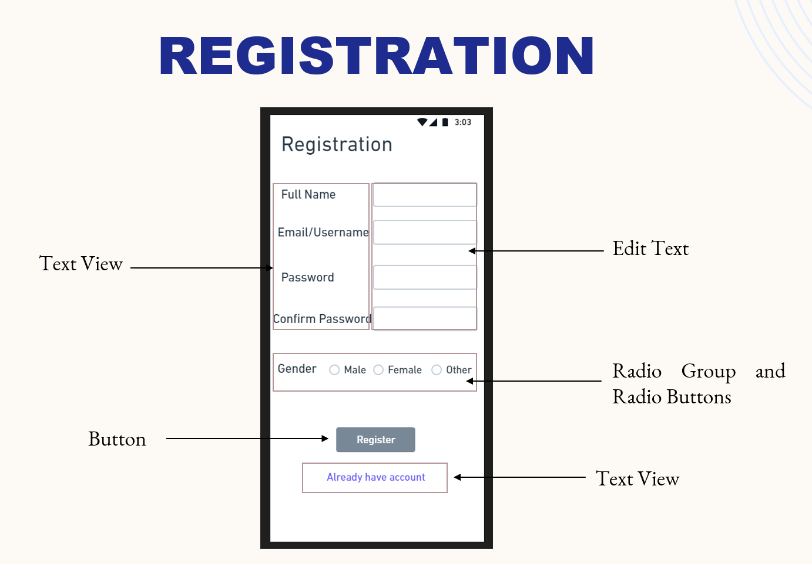

→ Users can register or create a New Account.

### 3.3 Appointment Booking



→ Users can book Appointments Online.

### 

### 3.4 Feedback

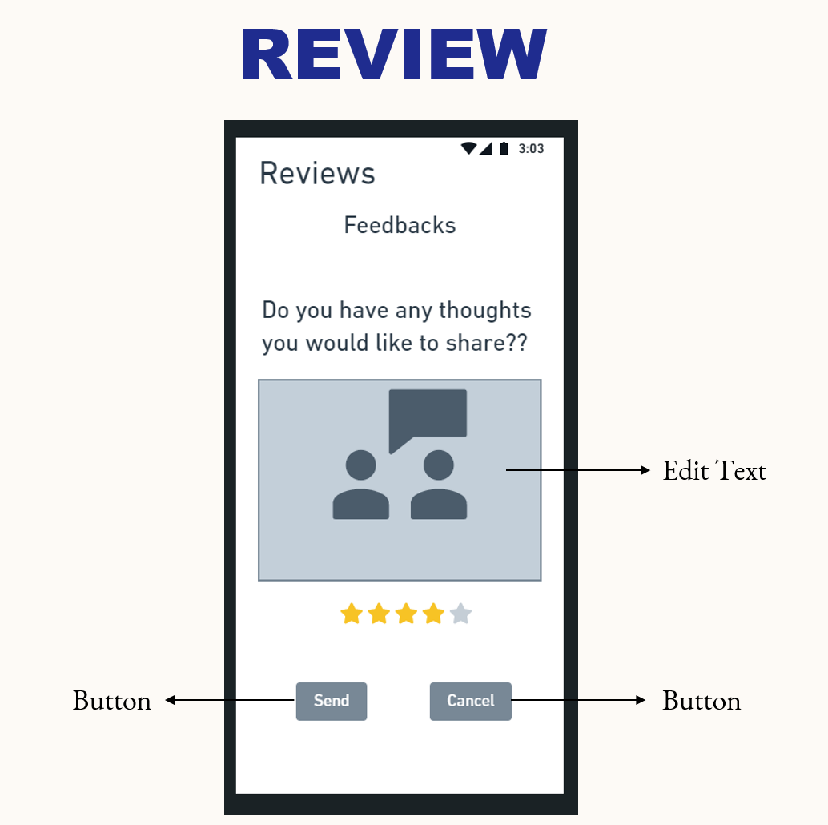

→ Users Can give feedback.

### 3.5 Timing

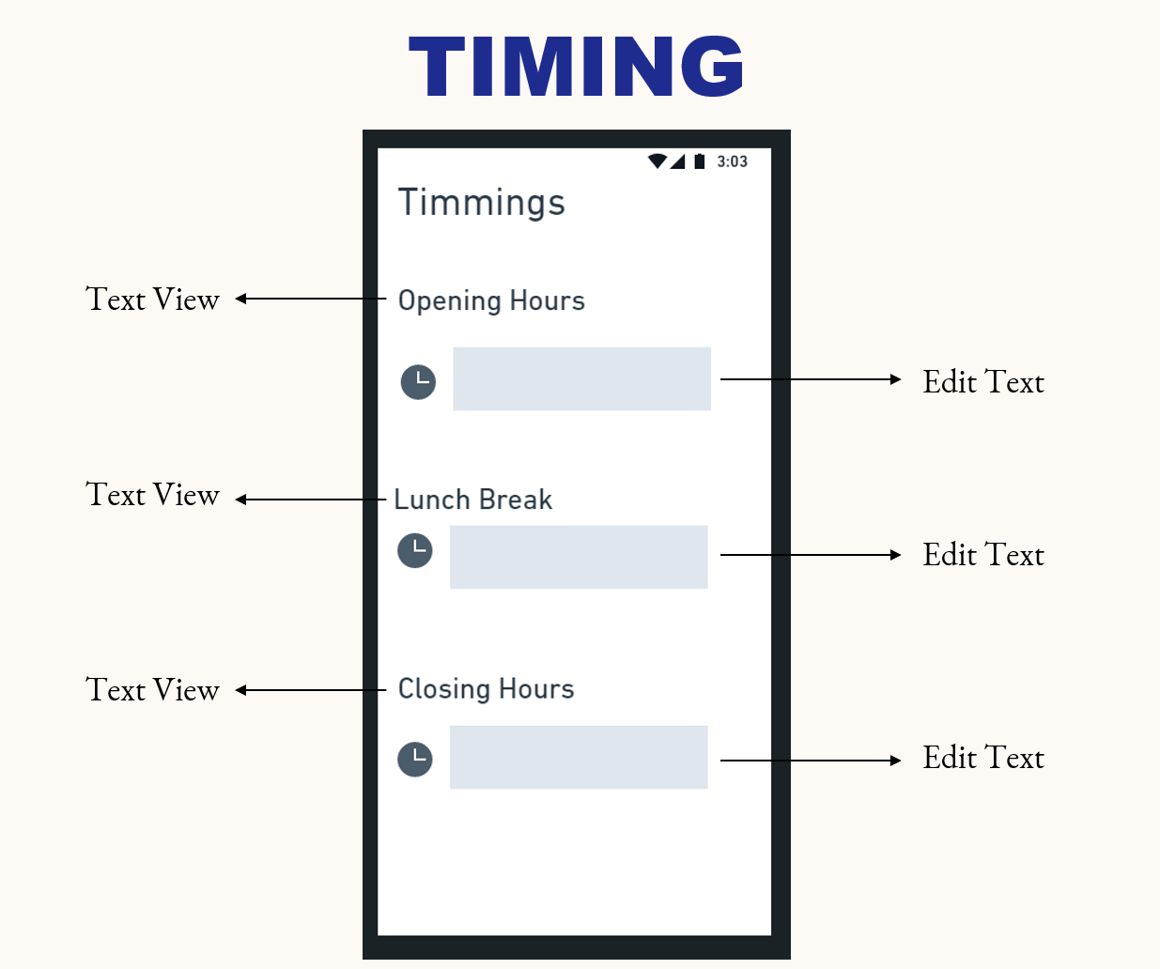

**→** Users Can View Opening, Closing and break times

### 3.6 Catalog

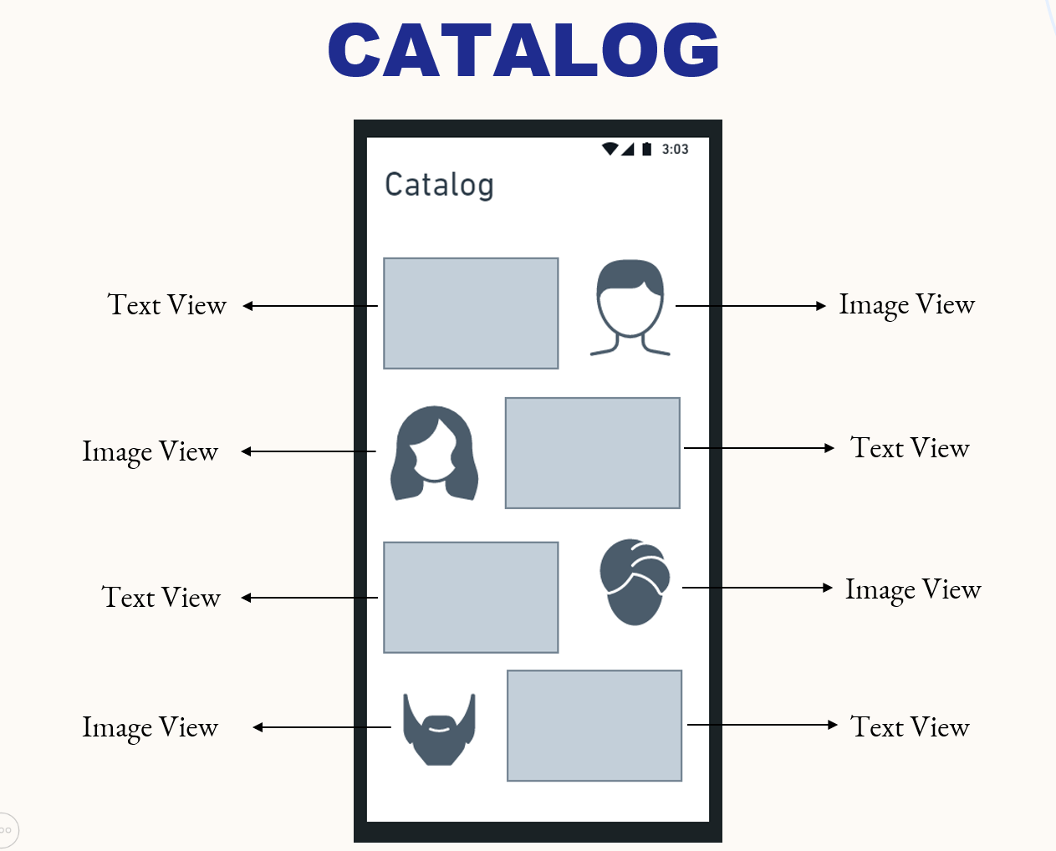

**→** Users Can View Catalog

### 3.7 Offers

**→** Users Can View New Offers

### 3.8 Staff Details

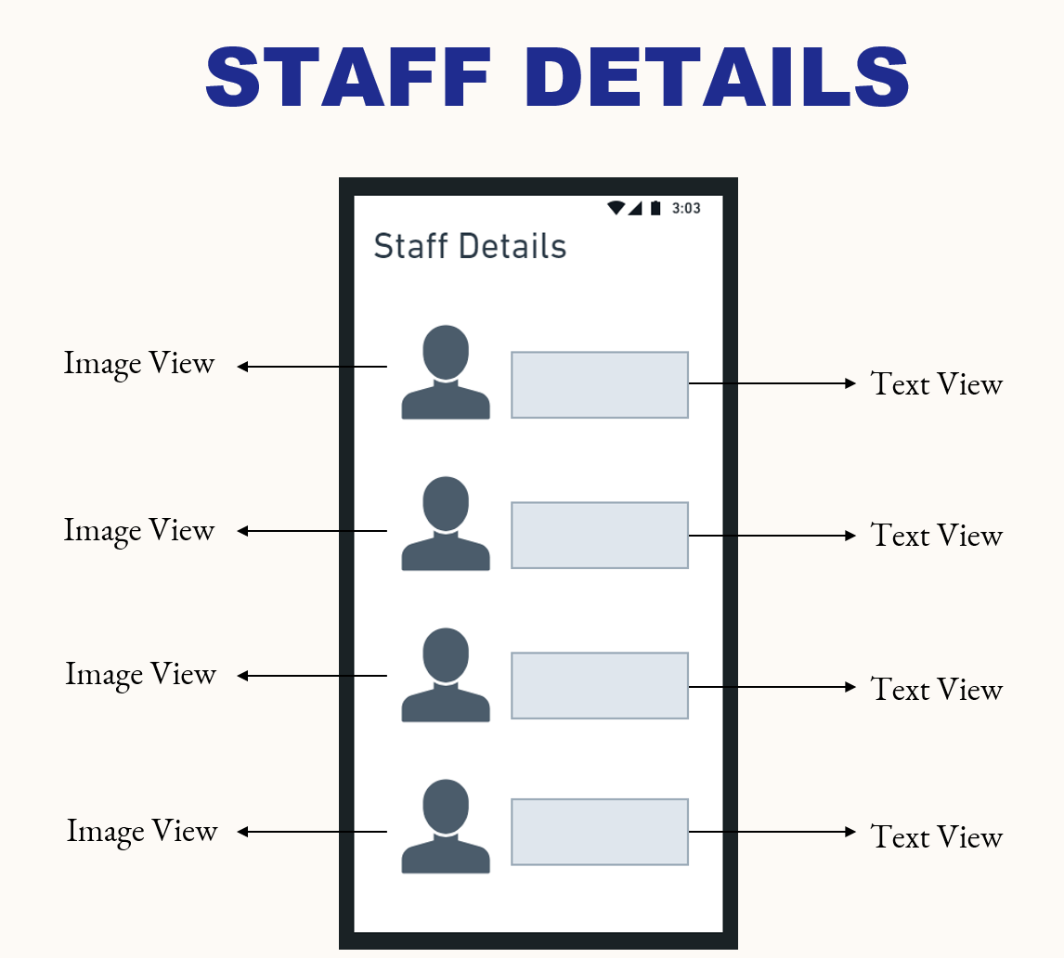

**→** Users Can View Staff Details

## 4. External Interface Requirements

### 4.1 User Interfaces

The application offers a sophisticated interface for users to enter their login credentials and access their accounts. When a user enters incorrect account information, such as an incorrect username or password, an error message will appear to let them know. A new user only has to sign up if they want to log into the application for the first time. The user can retrieve their password if they can't remember it.

### 4.2 Hardware Interfaces

Various interfaces for the product could be:

1. Android smartphone

### 4.3 Software Interfaces

Various interfaces for the product could be:

1.Android Operating System

2.Internet Connection

## 5. Other Non-functional Requirements

### 5.1 Performance Requirements

Increase customer satisfaction.

* The same resources of application can be used many times by a number of users.
* We have data backup so when any data is deleted, we can recover the data

### 5.2 Safety Requirements

•Both data and software should be backed up periodically.

•An off-site backup is necessary for recovery from major failure to ensure business continuity

### 5.3 Security Requirements

The user will submit their information, have the option to edit it, and the administrator will check the user's profile. The administrator can then update some of the features and add or remove user profiles as necessary.

## 6. Other Requirements

## Appendix A: Analysis Models

1. Flow Chart

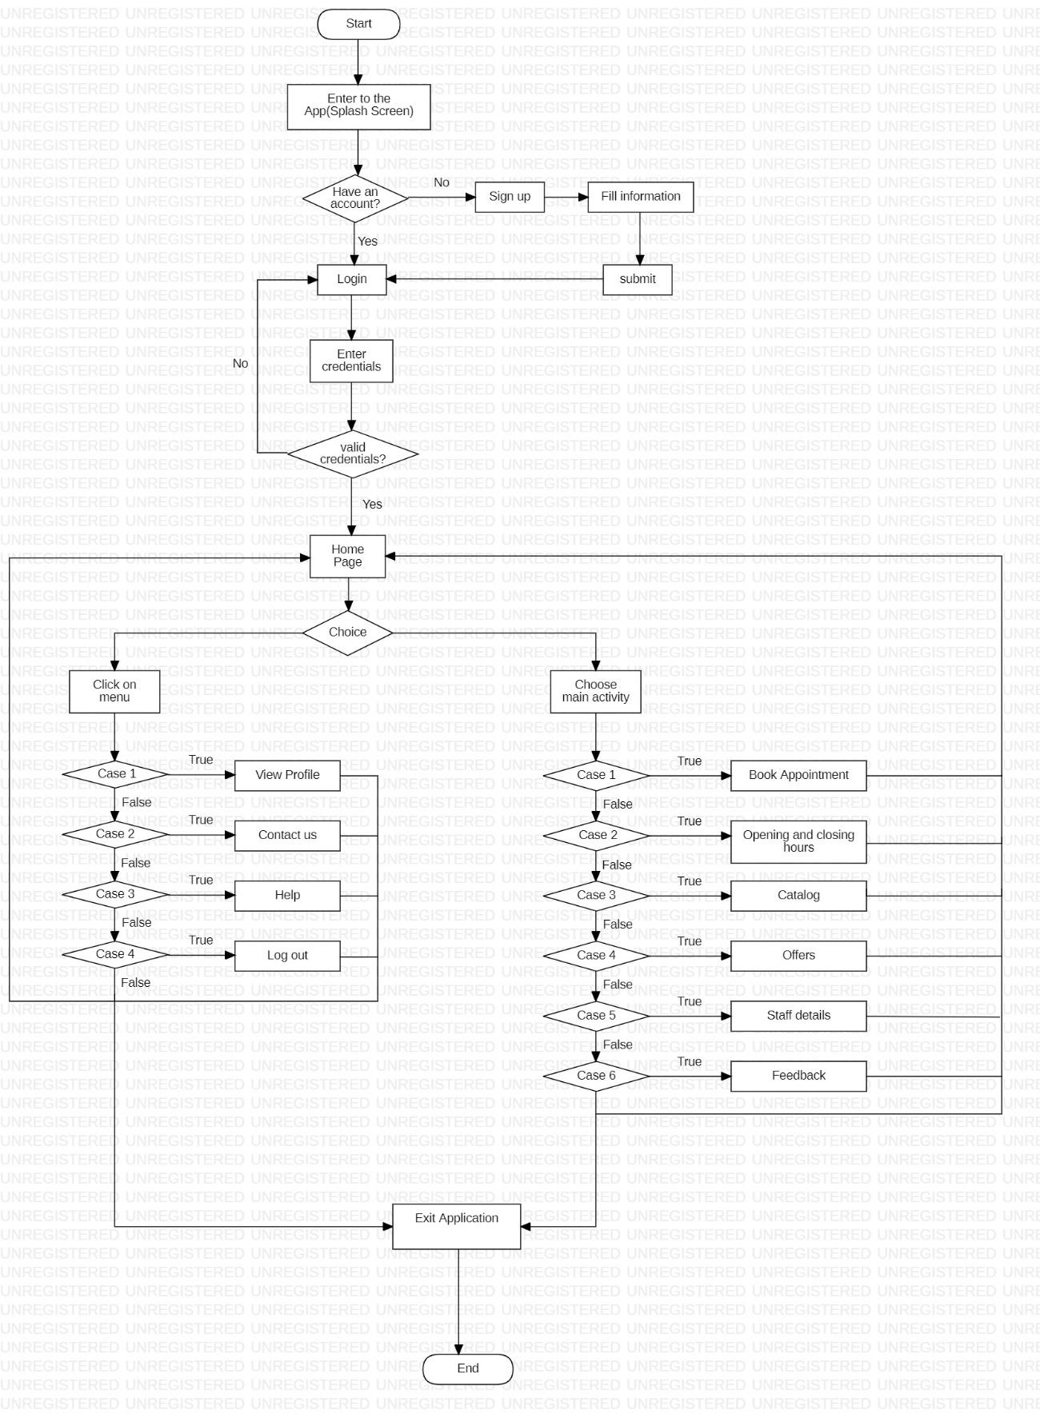

1. Class Diagram

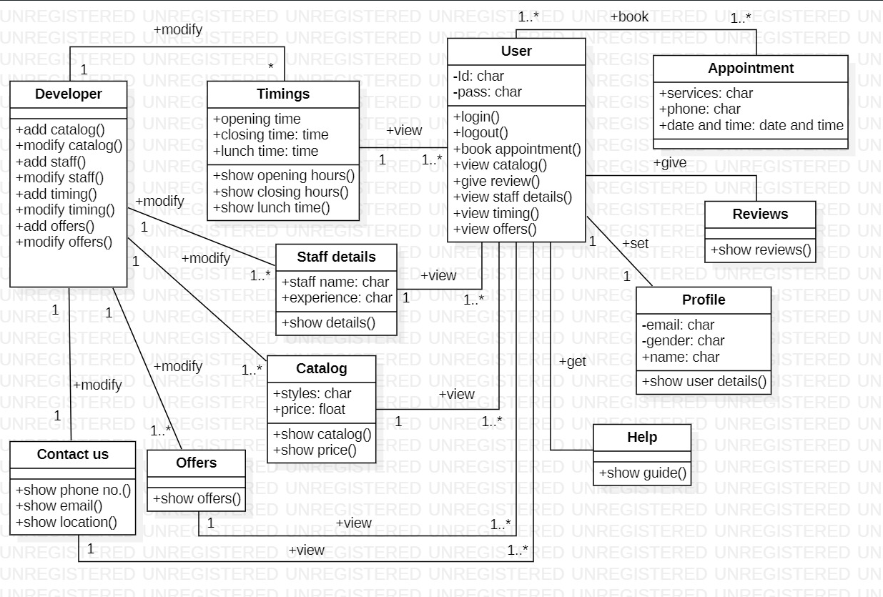

1. Use case Diagram

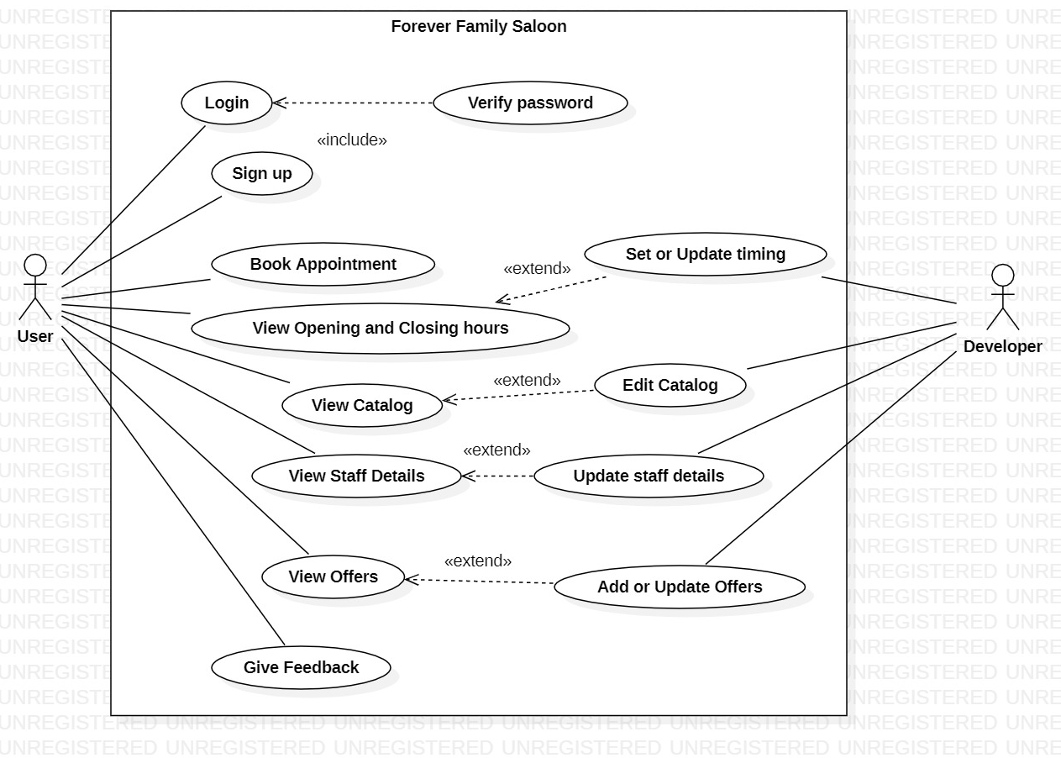

1. Activity Diagram

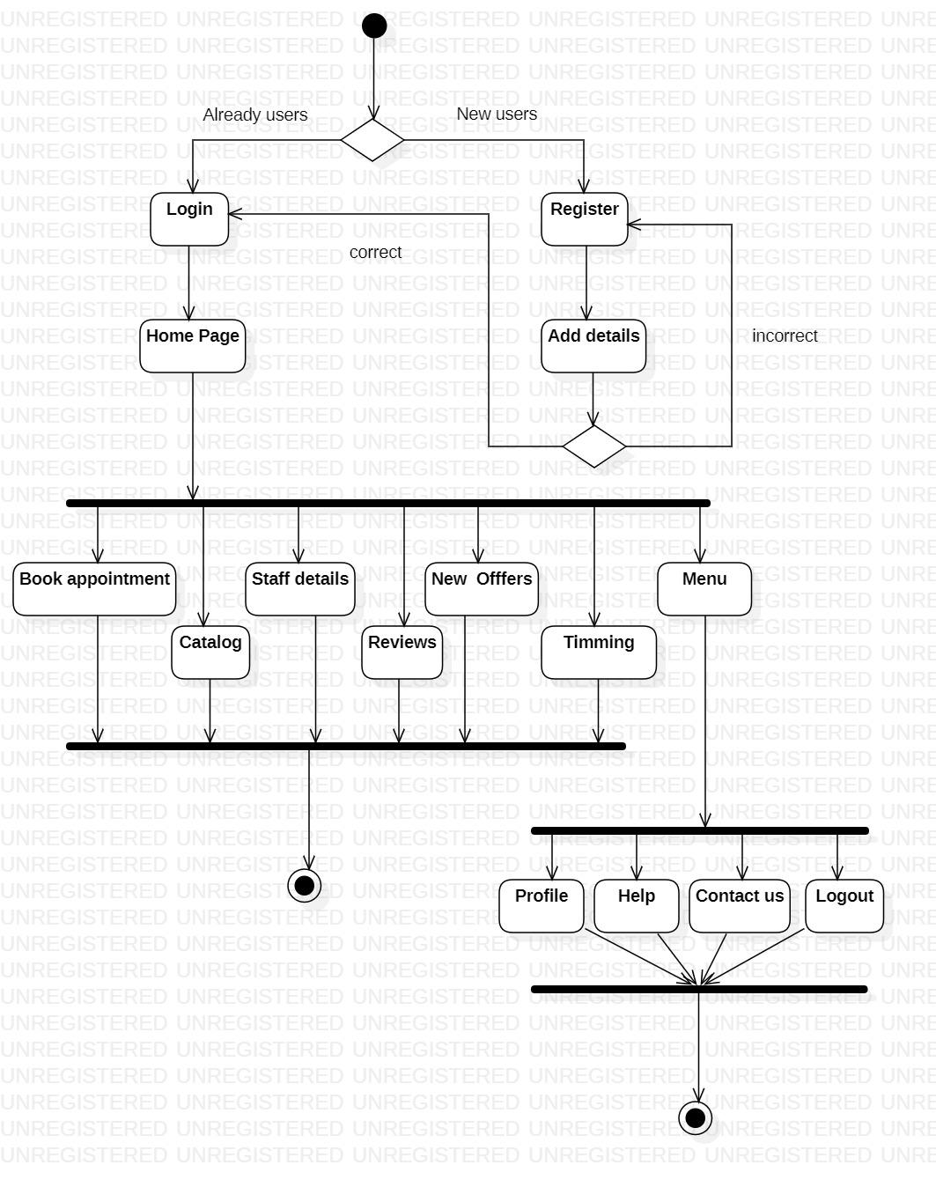

1. Sequence Diagram

## 

## 

1. ER Diagram

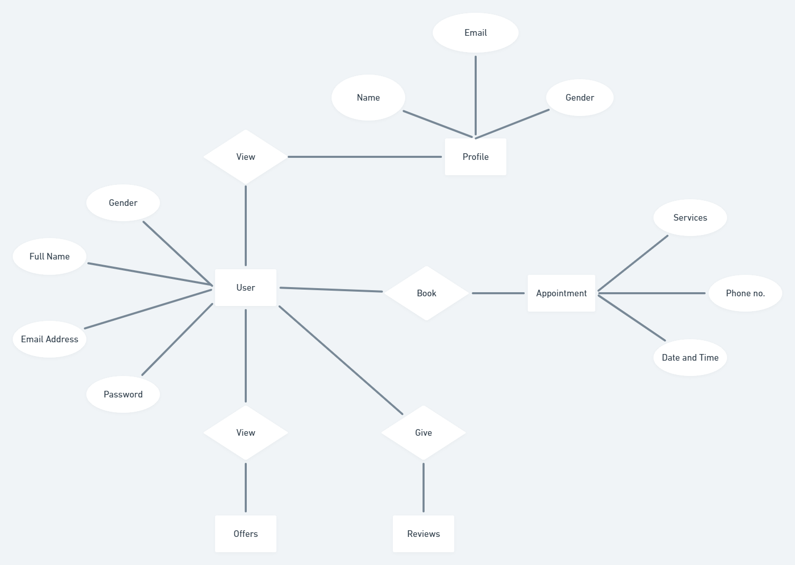

## Appendix B: Issues List

* Improper Authentication
* Software Maintenance complexity
* No optimisation for storage
* Basic and simple UI

## Wire Frame Component Description

